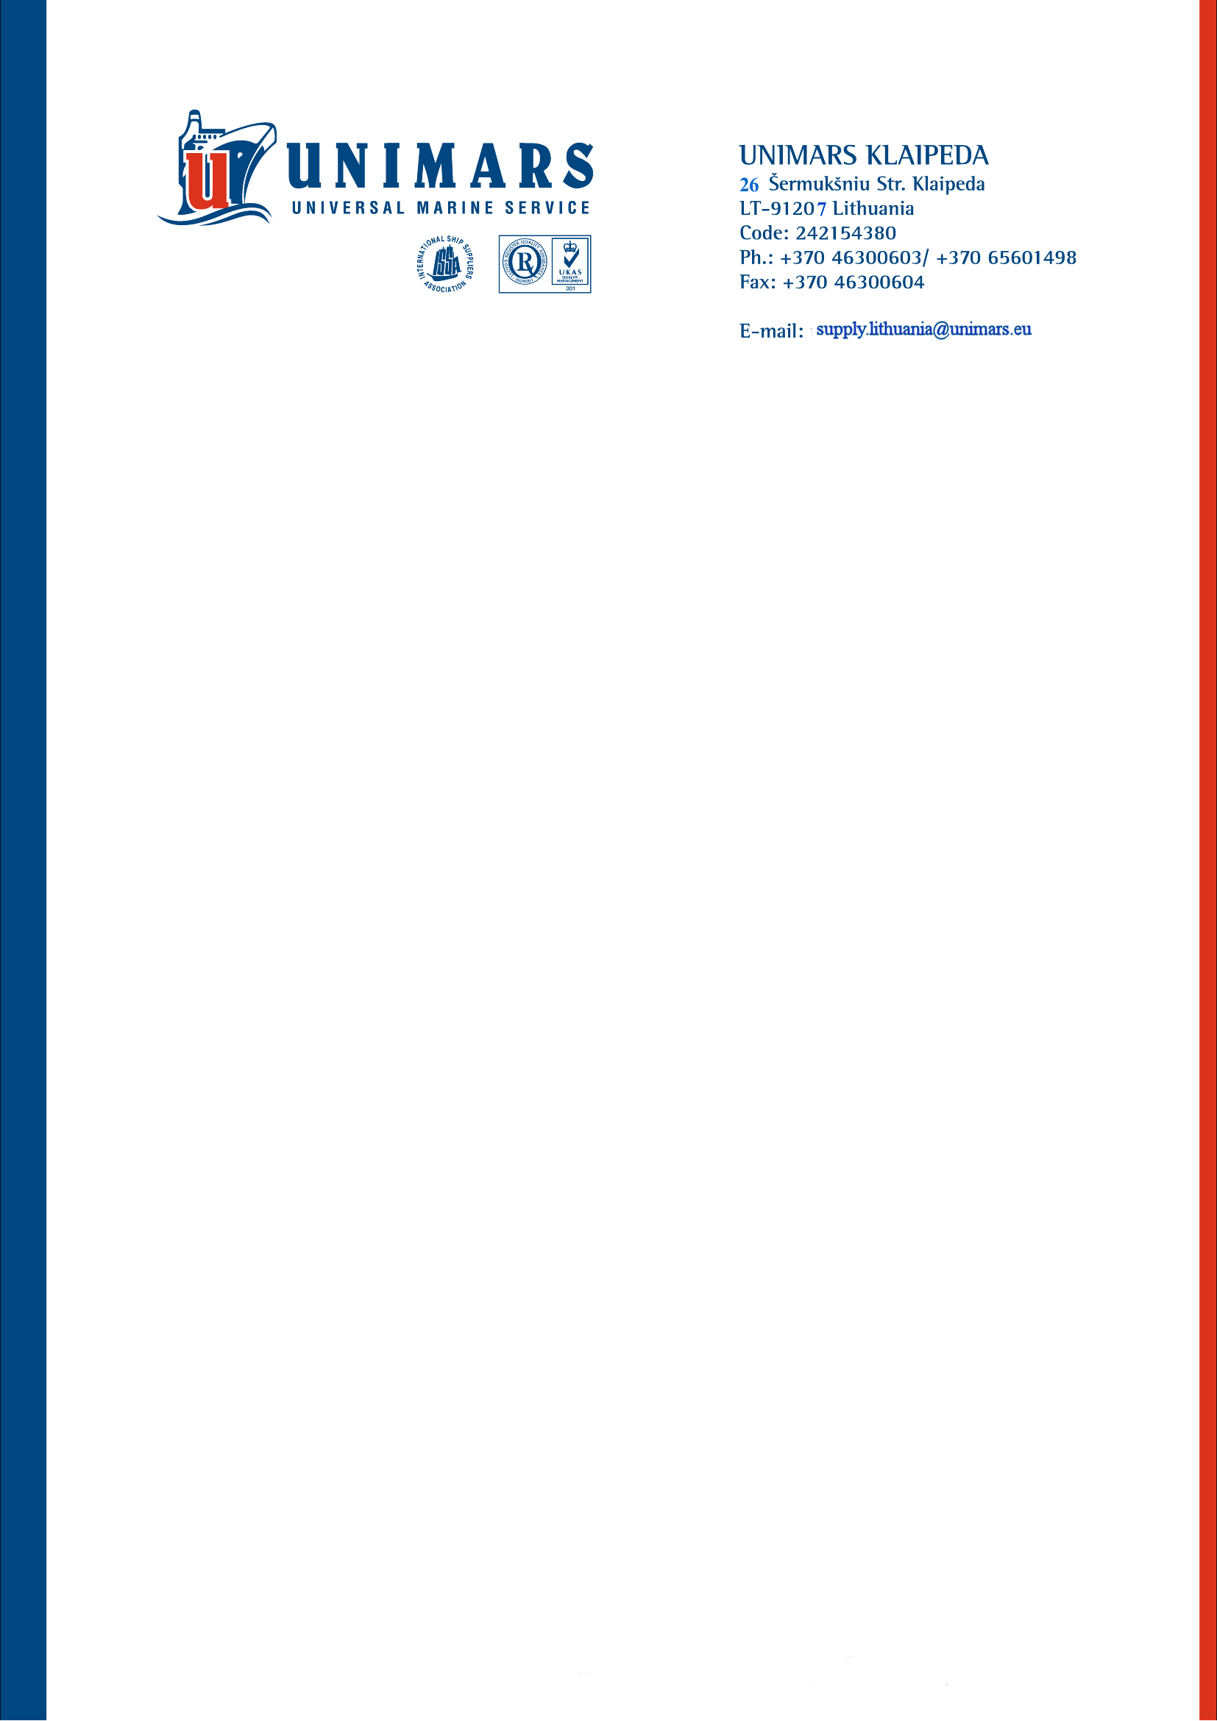

V SHIPS FRANCE SAS

CREDIT NOTE No. UNI 2026/03/21

March 30. 2026

Herewith we confirm that the company „Unimars“ (Klaipėda, Lithuania) has supplied m/v „ECO LEVANT“ according to following invoices:

- UNI 2603/22/B of March 30, 2026 – 615,00 EUR
Deducting 9.76% discount - - 60,00 EUR
Total net amount for payment is- 555,00 EUR

- UNI 2603/68 of March 30, 2026 – 695,10 EUR
Deducting 5.965% discount - - 41,46 EUR
Total net amount for payment is- 653,64 EUR

Total payment for the ship - 1208,64 EUR

__________________________
UAB “Unimars”
Manager Ina Selest

Bankas „SWEDBANK“ AB
Konstitucijos pr. 20A, Vilnius, Lithuania
S.W.I.F.T. :HABALT LT22
Account N..:LT40 7300 0100 9417 8770

